

**Data Technician**

|  |
| --- |
|  |

|  |
| --- |
| Name: Alaa Mostafa |
| Course Date: 16/12/24 |
|  |

**Table of contents**

Day 1: Task 1 2

Day 2: Task 1 2

Day 2: Task 2 3

Day 2: Task 3 4

Day 3: Task 1 4

Day 3: Task 2 5

Dataset: 5

Step 1: Create a Pivot Table 5

Step 2: Use the SWITCH Function 5

Submission: 6

Day 3: Task 3 6

Day 4: Task 1 7

Course Notes 9

Additional Information 10

# Day 1: Task 1

Please complete the below boxes on commons laws and regulations that must be followed when working with customers data, use the below bulleted list to support your answers.

* What is it
* Why is it important
* Provide a real-world example of how you can follow it
* How does it impact working with data
* What could happen if you breached it

|  |  |
| --- | --- |
| Data Protection Act | **What is it?**  * A UK law that governs how **personal data** is **collected, stored, used, and shared**. * Ensures individuals’ data is **handled legally and responsibly**. * The current version aligns with **GDPR** standards (DPA 2018).  **Why is it important?**  * Protects people’s **privacy** and **personal information**. * Builds **trust** between organizations and individuals. * Prevents **misuse or unauthorized access** to sensitive data.  **Real-world example of following it**  * A supermarket collects customer emails for a loyalty program but:   + Asks for **consent** before storing the email.   + Only uses it for **promotions**, not shared with third parties without permission.   + Keeps the data **secure and up-to-date**.  **Impact on working with data**  * You must:   + Only collect **necessary information**.   + Keep data **accurate and secure**.   + Follow proper **retention policies** (don’t store data longer than needed).   + Allow individuals to **access, correct, or delete their data**.  **Consequences of breaching it**  * Legal action and **fines** (can be up to £17.5 million or 4% of global turnover under GDPR/DPA). * **Damage to reputation** and loss of customer trust. * Potential **criminal liability** in severe cases. |
| GDPR | **What is it?**  * **General Data Protection Regulation (GDPR)** is an EU law protecting **personal data** of EU/EEA residents. * Ensures individuals have **control over their own data** and organizations process it **lawfully and transparently**.  **Why is it important?**  * Protects people’s **privacy and personal information**. * Encourages organizations to handle data **responsibly and securely**. * Builds **trust** between businesses and customers.  **Real-world example of following it**  * A fitness app collects user weight and health info:   + Users must **consent** to sharing their data.   + Data is used **only for fitness tracking**, not sold to advertisers.   + Users can **access, correct, or delete** their data anytime.  **Impact on working with data**  * Only **collect necessary data**. * Keep data **accurate, up-to-date, and secure**. * Inform individuals how their data will be used (**transparency**). * Respect users’ rights: access, rectification, deletion, portability, objection, etc.  **Consequences of breaching it**  * **Fines** up to €20 million or 4% of global turnover. * **Legal action** and regulatory investigation. * **Reputation damage** and loss of customer trust. * Possible **restriction from processing personal data** until compliant. |
| Freedom of Information Act | **What is it?**  * A UK law that gives the public the **right to access information** held by **public authorities** (e.g., government departments, councils, NHS). * Applies to **recorded information**, such as reports, emails, policies, and statistics.  **Why is it important?**  * Promotes **transparency and accountability** in public organizations. * Allows citizens to **understand government decisions** and public spending. * Supports **informed public debate and democracy**.  **Real-world example of following it**  * A citizen requests data on **local council spending**. * The council provides a **report or dataset** within the legally required time frame (usually 20 working days). * Sensitive data (e.g., personal information) is **redacted** to comply with other laws like GDPR.  **Impact on working with data**  * Public authorities must:   + Keep records **well-organized and accessible**.   + Respond to information requests **accurately and timely**.   + Consider **data protection** before releasing information.  **Consequences of breaching it**  * **Legal complaints** to the Information Commissioner’s Office (ICO). * Requirement to **release the requested information**. * **Reputational damage** and potential loss of public trust. * In serious cases, **financial penalties** may apply. |
| Computer Misuse Act | **What is it?**  * A UK law that **criminalises unauthorized access** to computer systems and data. * Protects against **hacking, malware, and other cybercrimes**.  **Why is it important?**  * Safeguards **sensitive information** from being stolen, altered, or destroyed. * Protects individuals, companies, and governments from **cyber attacks**. * Ensures a **legal framework** for prosecuting offenders.  **Real-world example of following it**  * An employee uses their work computer only for **authorized tasks**. * They **do not attempt to access restricted systems** or install unauthorized software. * Passwords and security protocols are **respected**.  **Impact on working with data**  * You must:   + Only access data you are **authorized to use**.   + Avoid **unauthorized changes or deletions** of files.   + Follow **password policies and cybersecurity measures**.  **Consequences of breaching it**  * **Criminal charges**, including fines and/or imprisonment. * **Legal action** against individuals or organizations. * Loss of **trust and reputation**. * Possible **civil lawsuits** for damages caused. |

# Day 2: Task 1

Please research and complete the following tasks within the retail-sales_dataset.xlsx document, paste a print screen into the provided boxes below:

1. In the sheet ‘retail_sales_dataset’ add all available data between columns A –J into a ‘table’
2. Using the ‘sort’ function, sort ‘Age’ to ‘largest to smallest’
3. Using the ‘SUM’ function, show me the commission total in cell ‘L10’
4. Using the ‘AVERAGE’ function, show me the average commission in cell ‘L11’

|  |  |
| --- | --- |
| Print screen 1 |  |
| Print screen 2 |  |
| Print screen 3 |  |
| Print screen 4 |  |

# Day 2: Task 2

Please research and complete the following tasks within the retail-sales_dataset.xlsx document, paste print screens into the provided box below:

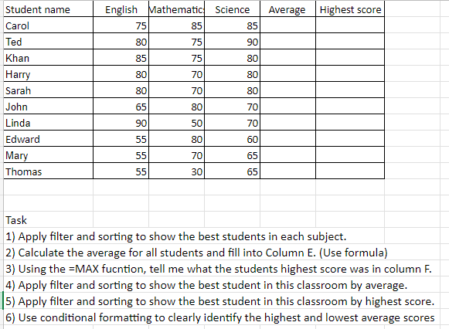

|  |  |
| --- | --- |
| Print screen 1 |  |

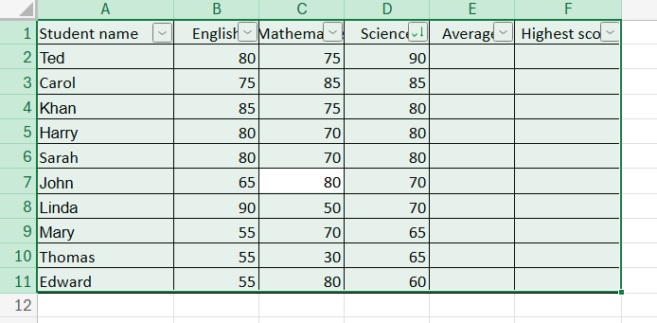

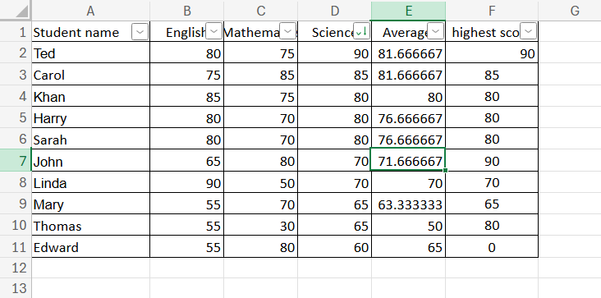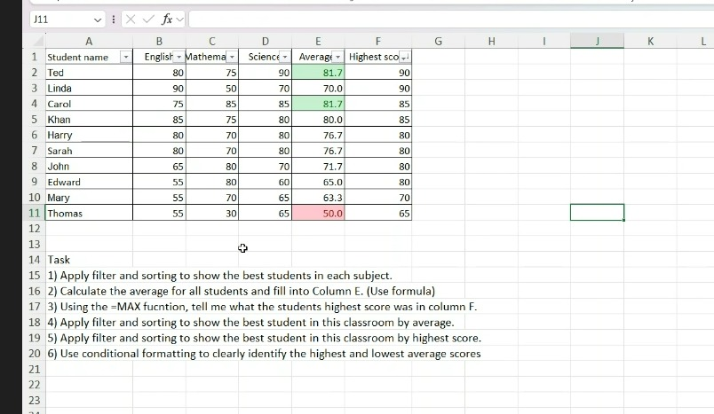

# Day 2: Task 3

Using the skills developed today, have some fun with the data set you have imported. Paste your work below and enjoy!

|  |  |
| --- | --- |
| Print screen 1 |  |

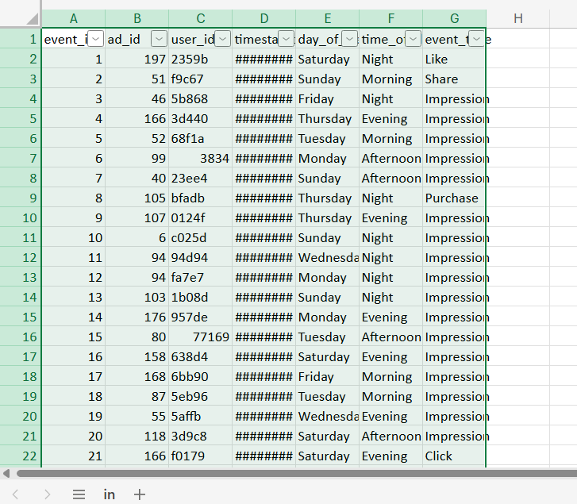

# Day 3: Task 1

Please download the dataset ‘Day_3_Task_1_Bike_Sales_Pivot_Lab.xlsx’ and the lab instructions.

Do not worry if you do not complete the lab, just working with data and playing with the pivot table will be good experience.

Please paste your final pivot table below and complete the reflection questions:

|  |  |
| --- | --- |
| Print screen 1 |  |
| In which markets does Germany have customers? | Germany has sales in all markets? Unsure as all the sales are for bikes. Bikes, Clothing, Accessories |
| What country has sales in all markets? | All of the countries do. |
| What are the most profitable markets by country, age group, and gender? | Country; us age group; adults gender;male |
| Any other findings? |  |

# Day 3: Task 2

The dataset below tracks the sales performance of different products in various counties in England. Please paste the dataset into a blank Excel workbook. Your task is to:

* **Create a Pivot Table** to summarise the data by county and product.
* **Use the SWITCH function** to categorise products based on their sales volume.

#### **Dataset:**

|  |  |  |
| --- | --- | --- |
| **County** | **Product** | **Sales Volume** |
| Yorkshire | Laptops | 500 |
| Yorkshire | Smartphones | 200 |
| Cornwall | Laptops | 700 |
| Cornwall | Printers | 400 |
| Lancashire | Smartphones | 150 |
| Lancashire | Laptops | 600 |
| Essex | Printers | 800 |
| Essex | Smartphones | 300 |
| Durham | Laptops | 250 |
| Durham | Printers | 300 |
| Greater Manchester | Smartphones | 600 |
| Greater Manchester | Laptops | 400 |

#### **Step 1: Create a Pivot Table**

* Select the dataset (columns A to C).
* Insert a Pivot Table to summarise the data by **County** in the rows and **Products** in the columns. Use **Sales Volume** as the value to be summarised.

#### **Step 2: Use the SWITCH Function**

In a new column next to your data, use the SWITCH function to categorise products based on **Sales Volume** as follows:

* + For sales greater than 600: **"High"**
  + For sales between 300 and 600: **"Medium"**
  + For sales less than 300: **"Low"**

**SWITCH Function Example**:

=SWITCH(TRUE, C2 > 600, "High", C2 >= 300, "Medium", "Low")

* Apply this formula to each row, and check if the products are categorised correctly.

#### **Submission:**

* A completed Pivot Table summarising sales by county and product.
* A new column in the dataset categorising products by sales volume using the SWITCH function.
  + Please paste your completed work below

|  |  |
| --- | --- |
| Print screen 1 |  |

# Day 3: Task 3

Please download the dataset ‘Day_3_Task_3_Bike_Sales_Visualisations_Lab.xlsx’ and the the lab instructions. Do not worry if you do not complete the lab, just working with data and playing with the charts will be good experience.

Please paste your results below:

|  |  |
| --- | --- |
| Print screen 1 |  |

# Day 4: Task 1

You have been asked to deliver your analysis findings to the board of directors, with your analysis you have identified that customers are leaving your company at the 12-month point, this is typically when they receive their renewal price.

Conduct research and complete the below questions:

|  |  |
| --- | --- |
| How would you prepare for the delivery? | * First, I’d make sure I understand exactly what the board wants to know. Are they looking for the root cause of churn? Do they want options for fixing it? Or do they mainly care about the financial impact? * Then, I’d go through the data carefully: check if the churn really spikes at 12 months, look at different customer groups, and rule out any data errors. * Next, I’d pull together the story: the problem → the proof → the impact → the options → the recommendation. * I’d practice delivering it so I’m confident, and prepare answers for tough questions like “How do we know price is the main issue?” or “What would it cost to fix this?”. |
| What tools would you use for the delivery? | * **Excel / Power BI** to clean up the data, run the numbers, and build scenarios. * **PowerPoint or Google Slides** to tell the story in a clean, simple way. * If I want the board to interact with the data (e.g. filter by product or region), I’d bring a live **Power BI dashboard**. |
| What is prospecting and why would you complete this before your delivery? | Before I go into the boardroom, I’d have quick chats with a few senior people. I’d share a simple one-pager or talk through my findings informally.  That way, I know what’s on their mind, I can sense where pushback might come from, and the final presentation won’t blindside anyone. It also makes them feel involved in shaping the message. |
| Tell me best practices for public speaking and providing updates to senior leaders | * **Lead with the headline** – tell them the key finding straight away. * **Keep it short and sharp** – senior people don’t have patience for long build-ups. * **Use visuals, not walls of text** – one clear chart says more than 10 bullet points. * **Know your stuff** – be ready to dive deeper if they ask. * **Stay calm and confident** – don’t rush, make eye contact, and treat it as a conversation, not a lecture. * **Have backup slides** – so if they want more detail, you’re ready. |
| What will you show the board in your delivery? | * **The problem**: “We’re losing customers at the 12-month mark, right when they see their renewal price.” * **The evidence**: churn curve charts, segmented by customer type, plus any feedback data. * **The impact**: how much revenue we’re losing, how it affects growth, and how much it costs us to replace lost customers. * **The options**: lowering or phasing in renewal increases, offering loyalty perks, improving service touchpoints. * **My recommendation**: which option makes the most sense, the trade-offs, and what decision I need from the board. |
| How will you articulate the changes that are needed? | * Use **clear, solution‐oriented language** (“We need to”, “I recommend”, “We should pilot”, etc.). * Frame changes via *options*, not demands — present multiple paths with trade‐offs. * Use visuals to compare “status quo vs proposed change” (before/after). * Quantify: what change will mean in financial terms, timelines, risk. * Highlight quick wins vs longer‐term fixes. |
| Provide a list of online resources and videos that will support your preparation for public speaking | * **Harvard’s tips on public speaking** * **TED Talks** – watch how great speakers simplify complex ideas (Simon Sinek is a good one). * **YouTube – Charisma on Command** – lots of practical tips on confidence and presence. * **Duarte & HBR articles** – great for learning how to speak to executives. |
| Evaluate tools that provide visualisation.  Tell me what they are.  Tell me what you would choose when delivering your presentation and why | * **Power BI** – best if your company already uses Microsoft. Interactive, great for showing trends and drilling down. * **Tableau** – slick visuals, great for storytelling, more flexible but often pricier. * **Google Looker Studio** – free and good for dashboards if you’re in the Google ecosystem. * **Excel** – still great for quick charts and financial models. |

|  |
| --- |
| **Course Notes** |

It is recommended to take notes from the course, use the space below to do so, or use the revision guide shared with the class:

|  |
| --- |
|  |

|  |
| --- |
| **Additional Information** |

We have included a range of additional links to further resources and information that you may find useful, these can be found within your revision guide.

**END OF WORKBOOK**

**Please check through your work thoroughly before submitting and update the table of contents if required.**

**Please send your completed work booklet to your trainer.**